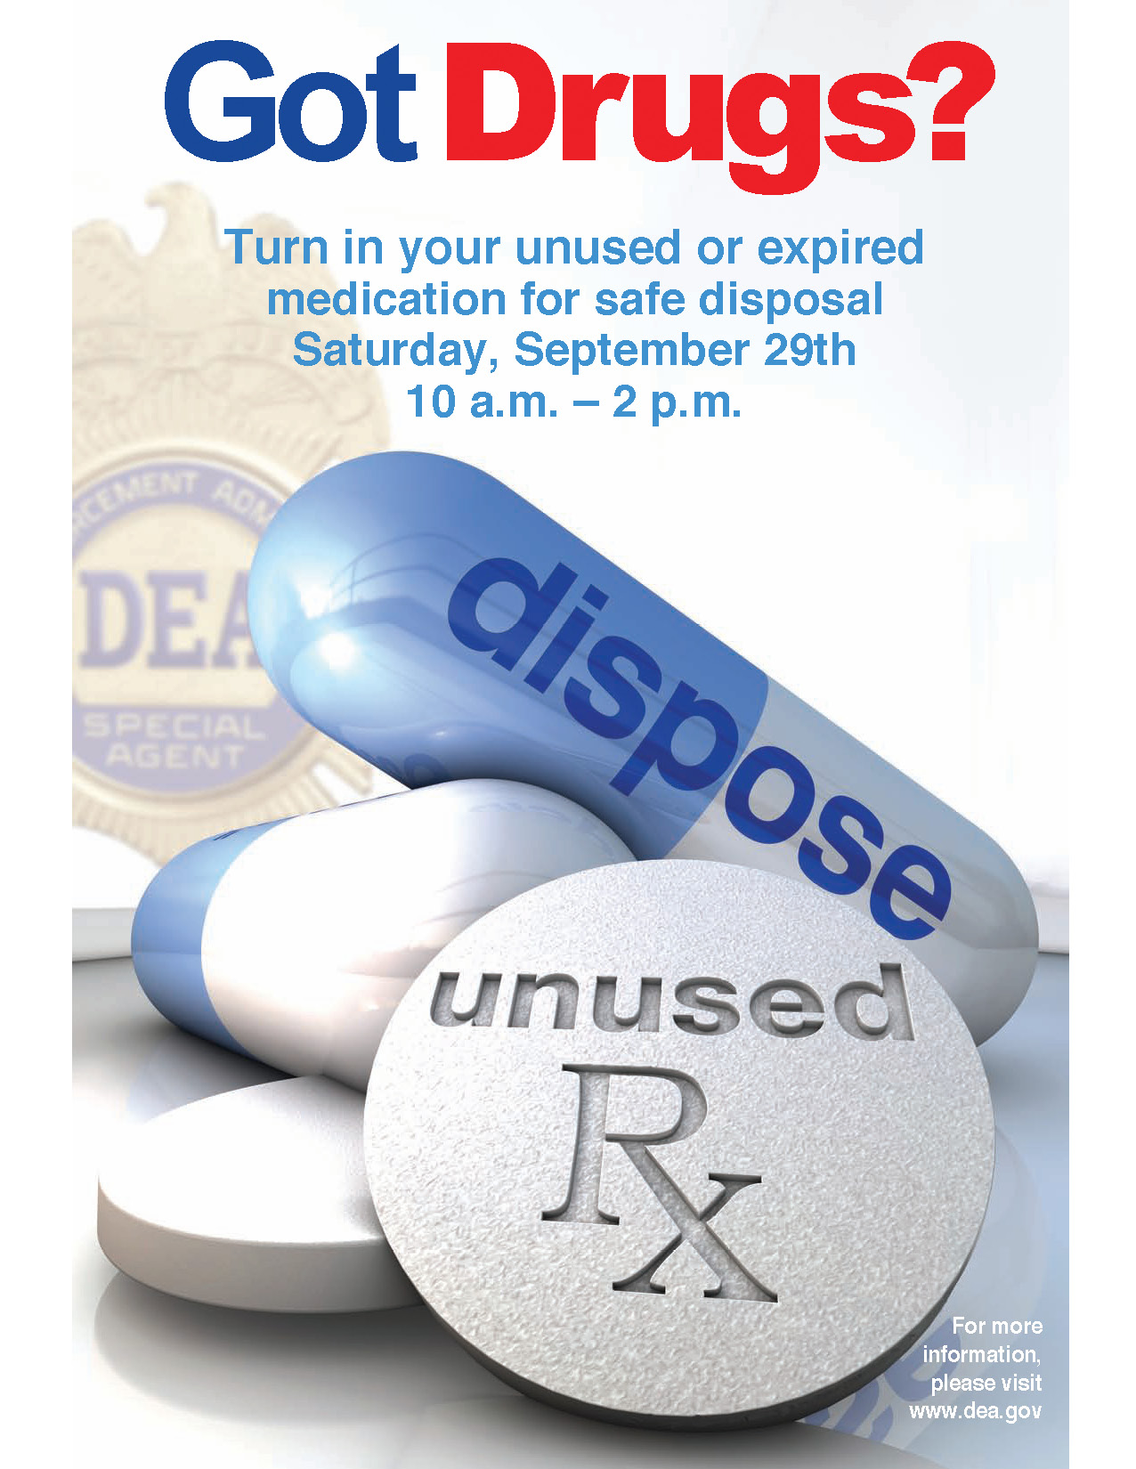



**Can’t go to the DEA event? Find a temporary take-back location in your community where available at** [**www.takebackyourmeds.org**](http://www.takebackyourmeds.org) **or call 1-888-869-4233**